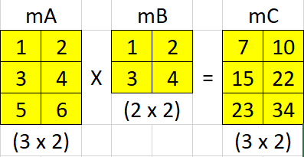

|  |  |
| --- | --- |
| **EX11-02a.cpp:** *Multiply Matrices* | |
| **Line#** | **Code** |
| 1  2  3  4  5  6  7  8  9  10  11  12  13  14  15  16  17  18  19  20  21  22  23  24  25  26  27  28  29  30  31  32  33  34  35  36  37  38  39  40  41  42  43  44  45  46  47  48  49  50  51 | #include <iostream>  using namespace std;  #define NOI(_arr) (sizeof(_arr)/sizeof(_arr[0]))  #define ROW(_m) NOI(_m)  #define COL(_m) NOI(_m[0])  #define showMatrix(_m) _showMatrix((double*)&_m, ROW(_m), COL(_m))  void _showMatrix(double* m, int row, int col) {  for (int c = 0; c < col; c++) cout << "------";  cout << endl;  for (int r = 0; r < row; r++) {  for (int c = 0; c < col; c++) {  cout << m[r * col + c] << '\t';  }  cout << endl;  }  for (int c = 0; c < col; c++) cout << "------";  cout << endl;  }  int main() {  double mA[][2] = {  {1,2},  {3,4},  {5,6},  };  double mB[][2] = {  {1,2},  {3,4},  };  if (COL(mA) != ROW(mB)) {  cout << "Cannot Multiply-lah!" << endl;  }  else {  double mC[ROW(mA)][COL(mB)];  for (int r = 0; r < ROW(mC); r++) {  for (int c = 0; c < COL(mC); c++) {  mC[r][c] = 0;  for (int i = 0; i < COL(mA); i++) {//For Sum-Product  mC[r][c] += mA[r][i] * mB[i][c];  }  }  }  showMatrix(mA);  cout << 'X' << endl;  showMatrix(mB);  cout << '=' << endl;  showMatrix(mC);  }  return 0;  } |

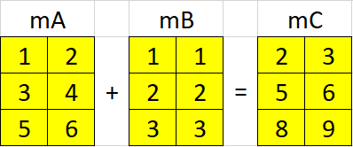

|  |  |
| --- | --- |
| **EX11-02b.cpp:** *Add Matrices* | |
| **Line#** | **Code** |
| 1  2  3  4  5  6  7  8  9  10  11  12  13  14  15  16  17  18  19  20  21  22  23  24  25  26  27  28  29  30  31  32  33  34  35  36  37  38  39  40  41  42  43  44  45  46  47  48  49  50  51 | #include <iostream>  using namespace std;  #define NOI(_arr) (sizeof(_arr)/sizeof(_arr[0]))  #define ROW(_m) NOI(_m)  #define COL(_m) NOI(_m[0])  #define showMatrix(_m) _showMatrix((double*)&_m, ROW(_m), COL(_m))  void _showMatrix(double* m, int row, int col) {  for (int c = 0; c < col; c++) cout << "------";  cout << endl;  for (int r = 0; r < row; r++) {  for (int c = 0; c < col; c++) {  cout << m[r * col + c] << '\t';  }  cout << endl;  }  for (int c = 0; c < col; c++) cout << "------";  cout << endl;  }  int main() {  double mA[][2] = {  {1,2},  {3,4},  {5,6},  };  double mB[][2] = {  {1,1},  {2,2},  {3,3},  };  if ((ROW(mA) != ROW(mB)) || (COL(mA) != COL(mB))) {  cout << "Cannot Add-lah!" << endl;  }  else {  double mC[ROW(mA)][COL(mA)];  for (int r = 0; r < ROW(mC); r++) {  for (int c = 0; c < COL(mC); c++) {  mC[r][c] = mA[r][c] + mB[r][c];  }  }  showMatrix(mA);  cout << '+' << endl;  showMatrix(mB);  cout << '=' << endl;  showMatrix(mC);  }  return 0;  } |

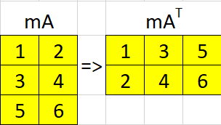

|  |  |
| --- | --- |
| **EX11-02c.cpp:** *Transpose Matrix* | |
| **Line#** | **Code** |
| 1  2  3  4  5  6  7  8  9  10  11  12  13  14  15  16  17  18  19  20  21  22  23  24  25  26  27  28  29  30  31  32  33  34  35  36  37  38  39  40  41  42  43 | #include <iostream>  #include <io.h>  #include <fcntl.h>  using namespace std;  #define NOI(_arr) (sizeof(_arr)/sizeof(_arr[0]))  #define ROW(_m) NOI(_m)  #define COL(_m) NOI(_m[0])  #define showMatrix(_m) _showMatrix((double*)&_m, ROW(_m), COL(_m))  void _showMatrix(double* m, int row, int col) {  for (int c = 0; c < col; c++) cout << "------";  cout << endl;  for (int r = 0; r < row; r++) {  for (int c = 0; c < col; c++) {  cout << m[r * col + c] << '\t';  }  cout << endl;  }  for (int c = 0; c < col; c++) cout << "------";  cout << endl;  }  int main() {  double mA[][2] = {  {1,2},  {3,4},  {5,6},  };  double mAt[COL(mA)][ROW(mA)];  for (int r = 0; r < ROW(mAt); r++) {  for (int c = 0; c < COL(mAt); c++) {  mAt[r][c] = mA[c][r];  }  }  showMatrix(mA);  _setmode(_fileno(stdout), _O_U16TEXT);  wcout << L"\u2193" << endl;  _setmode(_fileno(stdout), _O_TEXT);  showMatrix(mAt);  return 0;  } |